Given the root of a binary tree, return *the zigzag level order traversal of its nodes' values*. (i.e., from left to right, then right to left for the next level and alternate between).

**Example 1:**

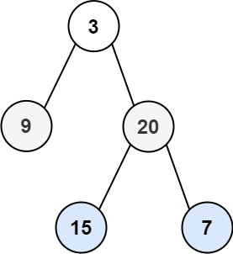

Input: root = [3,9,20,null,null,15,7]  
Output: [[3],[20,9],[15,7]]

**Example 2:**

Input: root = [1]  
Output: [[1]]

**Example 3:**

Input: root = []  
Output: []

**Constraints:**

* The number of nodes in the tree is in the range [0, 2000].
* -100 <= Node.val <= 100